Strategic Product Placement Analysis
Team ID: LTVIP2026TMIDS24136
1. INTRODUCTION
1.1 Project Overview
The Strategic Product Placement Analysis project is a comprehensive data-driven study designed to decode the complex relationship between spatial positioning and consumer purchasing behaviour. In the modern retail and media landscape, a product's success is determined not just by its quality or price, but significantly by its visibility and accessibility within its environment.
This project utilizes Tableau, a world-leading data visualization platform, to transform raw transactional data, shelf-mapping coordinates, and demographic logs into an interactive analytical ecosystem. By applying advanced data blending and visual analytics, the project aims to solve the "last mile" problem in marketing: ensuring that the right product is in the right place at the moment a consumer is most likely to buy.
1.2 Purpose
The primary purpose of this project is to establish a quantitative framework for measuring the impact of product positioning on commercial performance. In an era where data is the new currency, relying on "gut feeling" for product placement is no longer viable. This project aims to bridge the gap between psychological consumer theory and practical data.
2. IDEATION PHASE
2.1 Problem Statement
Retailers and production companies often lack a granular understanding of how placement affects the bottom line. Traditional reporting shows what was sold, but not where it was seen before the purchase. This leads to inefficient space utilization, underpriced advertising slots, and missed cross-selling opportunities where complementary goods are geographically or contextually isolated.
2.2 Empathy Map Canvas
The Empathy Map Canvas is a collaborative visualization tool used to articulate what we know about a particular type of user. In the context of Strategic Product Placement, we use this to shift our focus from "Total Sales" to the "Human Experience" behind the purchase. By understanding the sensory and emotional journey of a shopper or viewer, we can better interpret the patterns we see in our Tableau dashboards.
For this project, we observe the "Average Retail Shopper" to understand how placement influences their subconscious mind.

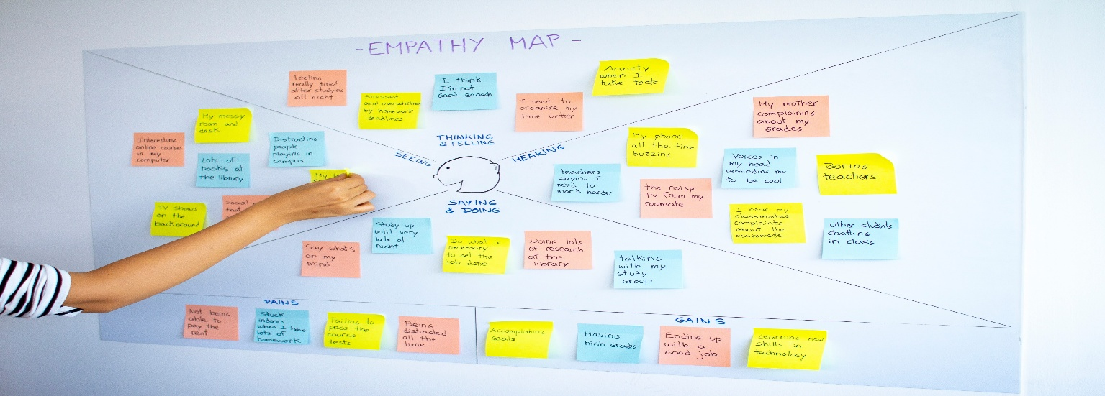

- Customer Pains: Frustration from cluttered layouts; "choice paralysis" when too many options are at eye level.
- Customer Gains: Ease of finding essentials; discovering new products through intuitive "path-to-purchase" layouts.
2.3 Brainstorming
The brainstorming phase was conducted to identify the most critical "Key Performance Indicators" (KPIs) and visualization techniques that would translate raw spatial data into actionable retail strategy. We focused on three main dimensions: Spatial Metrics, Consumer Correlation, and Economic Impact.
3. REQUIREMENT ANALYSIS
3.1 Customer Journey Map
The Customer Journey Map (CJM) is a strategic visual representation of the end-to-end experience a consumer has when interacting with a brand’s placement strategy. In this project, the CJM allows us to identify the specific "Touchpoints" where product positioning either succeeds in capturing attention or fails by being ignored.
The customer journey map must account for the psychological and environmental triggers that dictate movement through a space. A crucial aspect of this journey is the "Navigation Flow," where consumers subconsciously follow architectural cues—such as aisle width, lighting intensity, and flooring changes—to guide their path. For instance, in a retail environment, the transition from a wide, bright "Power Alley" to a narrower "Niche Category" aisle signals a shift from passive browsing to focused selection.
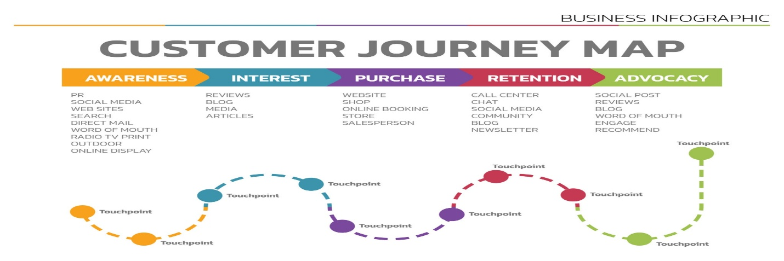
3.2 Solution Requirement:
The Solution Requirement centers on creating a high-performance analytical environment that is both flexible and intuitive. Systemically, the solution must support multi-source data integration, allowing the seamless merging of transaction logs, inventory metadata, and spatial store layouts
A critical requirement is interactivity; the dashboard must provide drill-down capabilities where users can click on a specific "hot spot" in a store map to reveal the underlying demographic data of the buyers. Furthermore, the system requires automated data refresh functionality to ensure that placement strategies are based on the most current sales trends rather than outdated quarterly reports.
3.3 Data Flow Diagram (DFD)
The Data Flow Diagram represents how information is captured from the physical world, processed through cleaning algorithms, and finally rendered as strategic insights in Tableau:
- Data Ingestion (External Entities): Raw data is gathered from three primary sources: POS (Point of Sale) Systems for transaction logs, RFID/Bluetooth Trackers for foot traffic, and Inventory Databases for product metadata (category, weight, margin).
- Data Transformation (Process 1.0): The raw data is often "noisy" (e.g., missing timestamps or inconsistent product names). We use Tableau Prep or Python to standardize the data, ensuring that "Eye-level Shelf" is labelled identically across all store datasets.
- Data Blending (Process 2.0): Here, we merge the "Where" (Spatial coordinates) with the "What" (Sales figures). This is the most critical step for our project, as it allows us to calculate the Sales Impact of a specific coordinate.
- Visualization Output (Process 3.0): The processed data is fed into the Tableau Engine to produce the final Heatmaps, Scatter Plots, and Trend Lines for the end-user (Retail Manager/Marketing Director).
3.4 Technology Stack
- SQL (MySQL / PostgreSQL): Used if the dataset is large; it allows for efficient querying and joining of "Sales Tables" with "Product Placement Tables."
- Python (Pandas/NumPy): (Optional) Utilized for advanced data cleaning, handling missing values, or calculating complex shelf-share percentages before importing into Tableau.
Visualization & Analysis
- Tableau Desktop: The core engine for creating interactive dashboards, spatial maps, and trend analyses.
- Tableau Prep Builder: Used to "shape" the data—cleaning, combining, and organizing disparate data sources into a single output file (. hyper) for faster performance.
- Geospatial Mapping: Using Tableau’s built-in mapping or custom background images to create "Store Floor Plan" visualizations.
4 PROJECT DESIGN
4.1 Problem Solution Fit
The Problem-Solution Fit for this project lies in the transition from static, spreadsheet-based reporting to dynamic, spatial data storytelling. Currently, retailers suffer from "data silos" where sales figures are disconnected from the physical reality of the store layout, making it nearly impossible to quantify the value of an end-cap display versus a standard shelf. Our solution addresses this by utilizing spatial mapping and heat-map overlays in Tableau, which visually anchor sales performance to specific XYZ coordinates within a store or digital interface. This allows stakeholders to immediately identify "Cold Zones" (high-traffic areas with low conversion) and "Golden Zones" (prime placements that maximize ROI).
4.2 Proposed Solution:
The proposed solution involves a multi-stage pipeline designed to bridge the gap between raw retail data and strategic business decisions:
- Automated Data Consolidation: A central repository will be created to merge disparate datasets—specifically sales transaction logs, product metadata (brand, price, category), and physical store coordinates.
- Multidimensional Interactive Dashboards: We developed a suite of dashboards that allow stakeholders to toggle between different views like the Heatmap View which Visualizes the "Hot" and "Cold" zones of the store based on foot traffic vs. purchase volume.
4.3 Solution Architecture:
The architecture for this project follows a linear, four-stage pipeline: Ingestion, Processing, Visualization, and Distribution. This ensures that raw product placement data is systematically refined into strategic sales insights:
- Data Ingestion Layer: The foundation of the architecture starts with collecting information on variables of interest, such as sales figures and product coordinates.
- Data Preparation & Processing Layer: This is the critical "cleaning" stage where the quality of the data is ensured to impact the accuracy of the results.
- Visualization & Analysis Layer: Complex data sets are converted into intuitive graphical representations to make them accessible and easier to interpret.
- Distribution & End-User Layer: The final stage involves delivering the insights to the stakeholders for decisions.
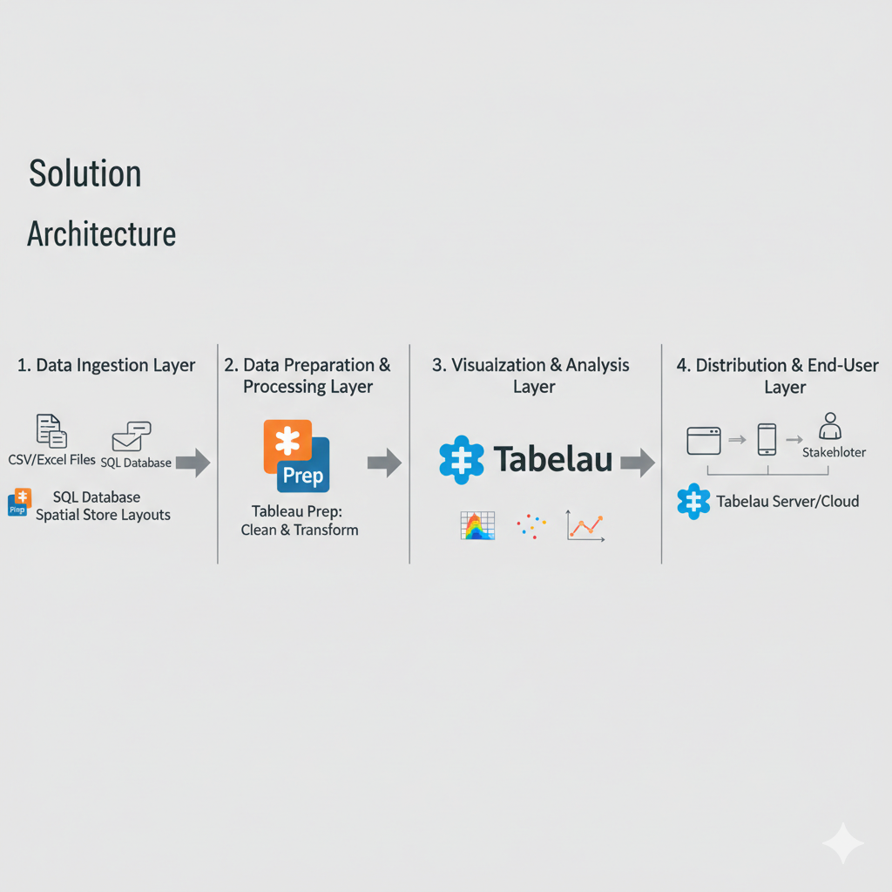
5. PROJECT PLANNING & SCHEDULING
5.1 Project Planning: The project planning is organized into three distinct phases to ensure a systematic transition from raw data to actionable business insights:
- Acquisition (Data Collection): This phase involves the systematic collection of information on key variables such as sales figures, product coordinates, and shopper demographics.
- Preparation (Data Cleaning & Blending): Raw data is often "noisy"; this step involves cleaning and transforming it to remove errors or inconsistent labels to ensure accuracy and reliability.
- Development (Visualization & Analysis): Using the Tableau engine, complex datasets are converted into intuitive visual elements like heatmaps, scatter plots, and trend lines.

6. FUNCTIONAL AND PERFORMANCE TESTING
6.1 Performance Testing: The most critical points to ensure our Tableau solution is fast and accurate are as follows:
- Filter & Dashboard Response: Verify that interactive filters and heatmaps load in under 3 seconds to maintain user engagement.
- Data Refresh Speed: Test how quickly the system ingests and processes new sales data from the acquisition phase into the visualization layer.
- Device Compatibility: Confirm the dashboard remains responsive and functional across desktops, tablets, and mobile devices for different stakeholders.
7. RESULTS
7.1 Output Screenshots
Home page:
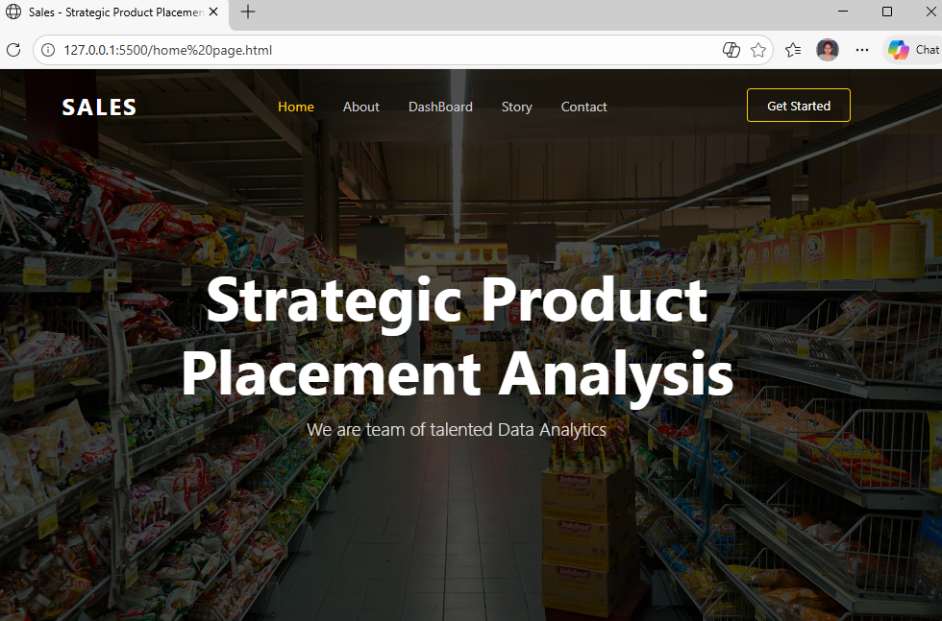
About Page:
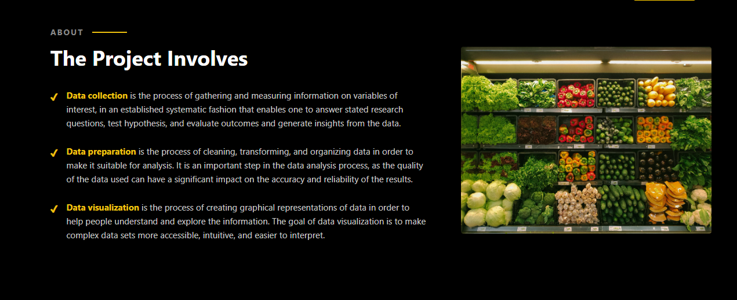
Dashboard Page:
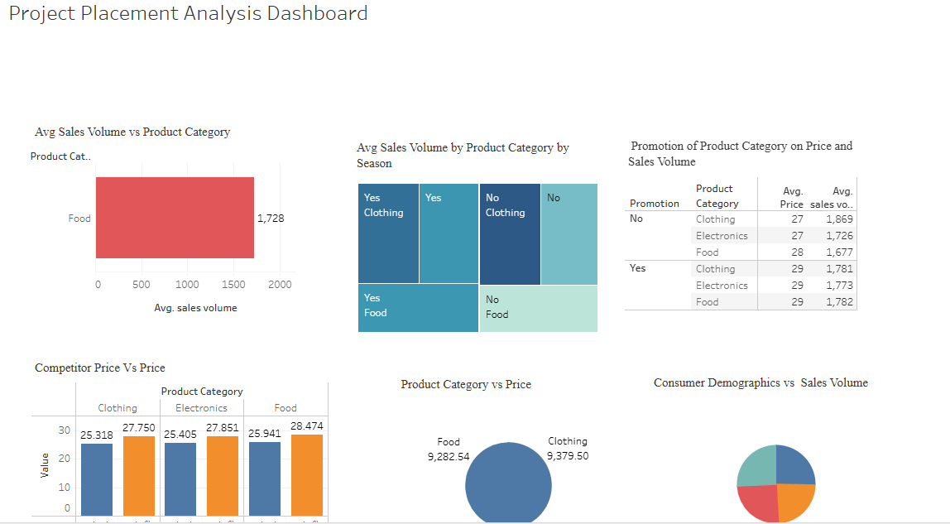

Story page:
Story Scene-1:
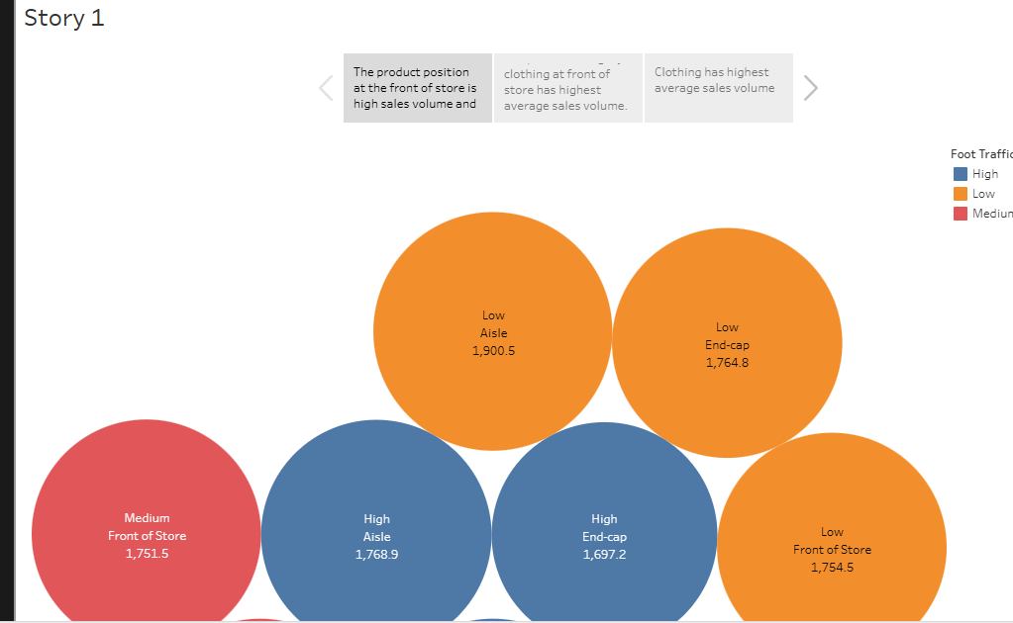
Story Scene-2:
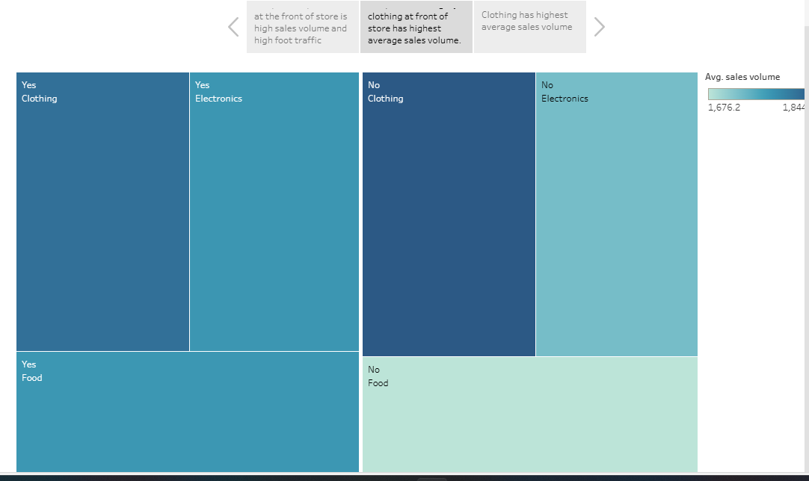
Story Scene-3:
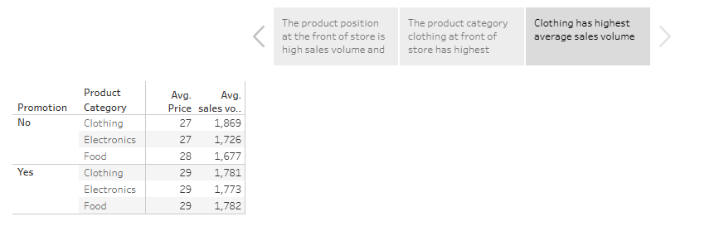
Contact Page:


8. ADVANTAGES & DISADVANTAGES
The major advantages include:
- Evidence-Based Strategy: It replaces "gut feelings" with visual evidence by using data visualization to identify clear patterns and trends in consumer behavior.
- Revenue Growth: The analysis uncovers which positioning strategies are most effective, allowing companies to optimize placements to directly drive revenue and boost
- Data Accessibility: Tableau simplifies complex datasets into intuitive graphical representations, making it easier for stakeholders to interpret and explore information.
Disadvantages include:
- Data Privacy Concerns: Collecting granular consumer demographics and foot-traffic data can raise significant privacy issues and requires strict adherence to data protection regulations.
- High Initial Setup Effort: Establishing a systematic data collection process from fragmented sources like POS systems and RFID trackers requires substantial time and technical resources.
- Dependency on Data Quality: The accuracy of the "Heatmaps" and "Sales Impact" insights is entirely dependent on the quality of the raw data,” noisy" or incomplete data can lead to misleading conclusions.
9. CONCLUSION
In conclusion, the project demonstrates that strategic product placement is a vital driver of revenue, transforming the retail environment into a "silent salesman" through data-driven insights. By leveraging Tableau to bridge the gap between physical store layouts and complex sales data, the analysis provides a clear visual roadmap for optimizing product positioning across retail, media, and advertising sector. Ultimately, the transition from raw data to interactive heatmaps and trend analysis empowers stakeholders to move beyond intuition, allowing them to make evidence-based decisions that enhance consumer engagement and maximize profitability.
10. FUTURE SCOPE
- Real-Time IoT Integration: Connecting dashboards directly to live IoT shelf sensors and RFID tags to monitor stock levels and placement effectiveness in real-time.
- Augmented Reality (AR) Overlays: Developing AR applications that allow retail managers to view predicted sales heatmaps overlaid directly onto physical store aisles through mobile devices.
- Advanced Sentiment Analysis: Integrating facial recognition or gaze-tracking data to correlate specific product placements with immediate consumer emotional responses and dwell times.
- Automated A/B Testing Creating a system that automatically rotates product placements across different store locations to conduct live A/B testing on shelf-share strategies.

